**VISVESVARAYA TECHNOLOGICAL UNIVERSITY BELAGAVI, KARNATAKA**

*A Mini Project Report*

***(Fifth Semester)***

*on*

**CLIENT MANAGEMENT SYSTEM**

*Submitted in the partial fulfillment for the requirements for the conferment of degree of*

**BACHELOR OF ENGINEERING**

in

**INFORMATION SCIENCE AND ENGINEERING**

by

**Mr. Manish Kumar Yadav**  USN: 1by20is078

**Mr. Mridul Sadashiv** USN: 1by20is090

**Mr. Lakshya Agarwal** USN: 1by20is072

Under the guidance of

**Dr. Sheela Kathavate**



**2021-2022**

# BMS INSTITUTE OF TECHNOLOGY & MANAGEMENT

**YELAHANKA, BENGALURU-560064**

# DEPARTMENT OF INFORMATION SCIENCE & ENGINEERING





This is to certify that Project (Fifth Semester) entitled **“CLIENT MANAGEMENT SYSTEM”** is a bonafide work carried out by **Mr. MANISH KUMAR YADAV (1BY20IS078)** and **Mr. MRIDUL SADASHIV (1BY20IS090)** and **Mr. LAKSHYA AGARWAL (1BY20IS072)** in partial fulfillment for the award of **Bachelor of Engineering Degree in Information Science and Engineering** of the Visvesvaraya Technological University, Belagavi during the year 2021-2022 It is certified that all corrections/suggestions indicated for internal assessment have been incorporated in this report. The mini-project report has been approved as it satisfies the academic requirements with respect to mini-project work for the B.E Degree.



**signature of the guide signature of HOD**

Dr. Sheela Kathavate Dr. Pushpa SK

**ACKNOWLEDGEMENT**

We are happy to present this Mini Project after completing it successfully. This Mini Project would not have been possible without the guidance, assistance, and suggestions of many individuals. We would like to express our deep sense of gratitude and indebtedness to each and every one who has helped us make this Mini Project a success.

We are grateful to **Dr. Mohan Babu G N,** Principal, BMS Institute of Technology & Management for his constant encouragement and support.

We heartily thank the Head of the Department, Information Science and Engineering, for her constant encouragement and inspiration in taking up this project.

We gracefully thank our guide**, Dr. Sheela Kathavate** Associate Professor, Dept. of Information Science and Engineering, for her encouragement and advice throughout the course of this project work.

Nevertheless, we express our gratitude towards our family and friends for the encouragement and support which helped us to finish this project successfully.

BY,

**MANISH KUMAR YADAV**

**MRIDUL SADASHIV**

**LAKSHYA AGARWAL**

**DECLARATION**

We, hereby declare that the Mini Project titled “CLIENT MANAGEMENT SYSTEM” is a record of original Mini Project work undertaken for the award of the degree of Bachelor of Engineering in Information Science and Engineering of the Visvesvaraya Technological University, Belagavi during the year 2022-23. We have completed this Mini Project work under the guidance of **Dr. Sheela Kathavate,** Associate professor, Dept. of ISE.

I also declare that this Mini Project report has not been submitted for the award of any degree, diploma, fellowship or other title anywhere else.

**Student Photos: Photo1 Photo2 Photo3** 



**ABSTRACT**

The “CLIENT MANAGEMENT SYSTEM” is a software tool or platform that helps businesses to manage interactions and relationships with their clients or customers. A CMS can be used to track and organize information about clients, such as contact information, purchase history, and communication records. It can also help businesses automate tasks related to client management, such as sending out invoices or following up on leads.

A CMS can typically be accessed by different departments within a business, such as sales, customer service, and accounting, which allows for more streamlined communication and coordination between teams. Some CMSs also include features for managing client interactions and communication, such as email and messaging tools, and can also provide reports and analytics on client activity and engagement.

Overall it helps businesses to better manage client communication, data, and activities, which can ultimately help to improve customer satisfaction and retention, as well as sales and revenue.

In addition to the features I mentioned earlier, many client management systems also include

1. Lead Management: A CMS can help businesses track and manage leads, from initial contact to conversion. It can also help to prioritize leads based on factors such as demographics, purchase history, and communication preferences.
2. Sales Management: A CMS can assist sales teams in tracking and managing sales pipelines, forecasting future sales, and identifying potential upsell or cross-sell opportunities.
3. Marketing Automation: Some CMSs include marketing automation tools that can help businesses to create and manage email campaigns, automate social media posts, and analyze marketing performance.
4. Project Management: A CMS can help businesses to manage and track client projects, including project timelines, milestones, and progress.
5. Customer Service Management: A CMS can also help businesses to manage and track customer service requests, including creating and assigning tickets, managing customer interactions, and analyzing customer satisfaction levels.

## **TABLES OF CONTENTS**

Chapter CHAPTER NAME Page No.

No.

1 Introduction

1.1 Outline

1.2 Motivation and Scope

1.3 Problem Statement

1.4 proposed solution

2 Requirement Specification

2.1 Functional Requirements

2.2 Non-Functional requirement

2.3 Domain Constraints

3 System/Requirement Analysis

3.1 Overall System Design

3.2 Admin Module

3.3 Admin/Client Module

4 System Design

4.1 Entity Relationship Diagram

4.2 Schema Diagram

5 Implementation

5.1 Description of Database tool

5.2 Description of implementation(Frontend)

6 Testing

6.1 Component Testing

6.2 System Testing

7 Interpretation of Results

Conclusion

References

Department Vision and Mission

**LIST OF FIGURES AND TABLES**

| Figure No. | TITLE |
| --- | --- |
| 3.1 | Overall System Design |
| 3.2 | Admin Module |
| 3.3 | Admin/Client Module |
| 4.1 | ER Diagram |
| 4.2 | Schema Diagram |
| 6.1 | Component Tests |
| 6.2 | System Tests |
| 7.1 - 7.10 | Interpretation of Results |

**CHAPTER 1: INTRODUCTION**

* 1. **Outline:**

This web application provides facility to manage the clients and provide them services efficiently and effectively. This application stores the data of client and manages it between admin and client.

##### **Motivation and Scope:**

The Scope of this project is very broad in terms of gaining knowledge and sharing knowledge among the world.

Few points are:-

* + - Can be used anywhere any time as it is a web-based

application.

* + - This application will be used in educational institutions as well as in the corporate world.
  1. **Problem statement:**

“Our aim is to develop an application for the users in which a client can easily access all the services and subscribe to it”. Many sites or web applications are not there in the market provide these services through websites. Even if they provide they charge huge amounts that a company doesn’t want to pay directly on a web application. Hence customer support is also not available in these applications.

**In the Client Management System Project, we use PHP and MySQL Database. This project keeps the records of clients. The client Management System has two modules ie. Admin and client. In this application, a client keeps track of what is the status of its invoice and services provided.**

### **Proposed Solution**

A client management system (CMS) is a software application that businesses can use to organize and automate their interactions with clients.

Streamlining operations, CMS can be used to store contact information for clients, making it easy for employees to access and communicate with them. It can also facilitate communication between different departments within a business, such as sales and customer service.

Client management can collect data on customer interactions and behavior, which can be analyzed to gain insights into customer needs and preferences, which can inform business strategies and decision-making.

* These are the various solutions solved through different modules of web applications.
* The brief about these functions is explained in the next topic .

#### **CHAPTER 2:** **SYSTEM REQUIREMENT ANALYSIS**

**2.1 Functional Requirement**

The main purpose of a client management system (CMS) is to help businesses manage their interactions and relationships with clients or customers. A CMS can be used to organize and track information about clients, as well as automate tasks related to client management.

**Account Login:** The system shall require a user to log in, in order to carry out any operations in the software. It will ask the user for information like username, password, and various other relevant fields. The User Creates an account as Admin which has the all details of their clients.

**Managing Services:** User can manage their services easily. They can add or remove services according to their need.

**Sales Management:** Client management system is used for managing the sales pipelines and helps in identifying potential upsell or cross-sell opportunities.

**Dashboard:** In this section, the admin can briefly view the total services, total clients, total today’s sales, total yesterday’s sales, last seven day’s sales, and total sales.

**Services:** In this section, the admin can manage services (Add/Update).

**Add Clients:** In this section, the admin can add new clients

**Clients List:** In this section, the admin can update the client details and add services that are provided by the admin.

**Invoices:** In this section, the admin can view the invoices of the client and also take print of the invoice.

**Reports:** In this section, the admin can view the client’s details and check the sales reports(month-wise/year wise) in a particular period.

**Search Invoice:** In this section, the admin can search for clients’ invoices with the help of his/her invoice number.

Admin can also update his profile, change the password and recover the password.

**Dashboard:** It is a welcome page for a client.

**Invoices:** In this section, the client can view the invoices of the client and also take print of the invoice.

**Search Invoice:** In this section, the client can search for his/her invoice with the help of the invoice number.

The client can also update his/her profile, change the password and recover the password.

**2.2 Non-functional Requirement:**

**Performance:** The response time of the System should be less than 3 seconds most of the time. Response time refers to the waiting time while the system accesses, queries, and retrieves the information from the databases.

**Reliability:** It shall be available 24 hours a day, 7 days a week. It shall always provide accurate information to the user whenever accessed.

**Integrity:** Only the system administrator has the right to change system parameters, such as deleting unwanted/spam details concerned users/organizations and client details.

Users need to be authenticated before having access to any data.

A Convenient dashboard, user-friendly UI, separation of working pages for user

convenience, and separate dashboards for client and admin are a must.

**CHAPTER 3: SYSTEM/REQUIREMENT ANALYSIS**

**3.1 Overall System Design:**

The first step in our project was having a discussion about what functionalities we wanted to provide with our work. After getting a mutual understanding of what the end product might look like, we worked on the database design.

The two of us made our own database schema, compared them, and put together a final database schema that we all could agree upon, with parts of all our works to make what we deemed to be the most functionally accurate database.

The next step was frontend development (using HTML + CSS ) and database creation (using MySQL), both of which were done simultaneously. The frontend was made with regular interaction with the backend-in-charge, to make sure it properly reflects the backend and at the same time is user-friendly.

##### 

**Admin Module:**

In the admin module these are the section present, Services is where the admin can manage services (Add/Update).In the Add Clients section,the admin can add new clients. Clients ListIn this section, the admin can update the client details and add services that are provided by the admin.

In the invoices section, the admin can view the invoices of the client and also take a printout of the invoice. In Reports, the admin can view the client’s details and check the sales reports(month-wise/year wise) in a particular period. To find a particular invoice, the admin can search for clients’ invoices with the help of his/her invoice number.

Admin can also update his profile, change the password and recover the password.

**Client Module:**

On the client side of the software these sections are present. First on logging in the client land on Dashboard, which is a welcome page for a client.

If the client needs to see the invoices, the invoices section is there for this purpose. In this section, the client can view the invoices of the client and also take the print off of the invoice. Search Invoice In this section, the client can search for his/her invoice with the help of the invoice number.

The client can also update his/her profile, change the password and recover the password.

**CHAPTER 4 - SYSTEM DESIGN**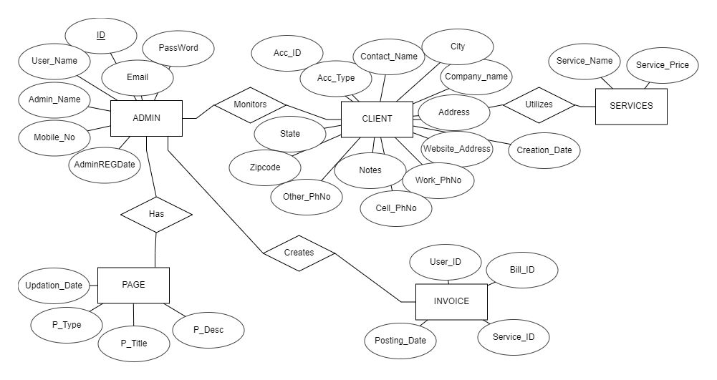

ENTITY RELATIONSHIP DIAGRAM:

**SCHEMA DIAGRAM:**

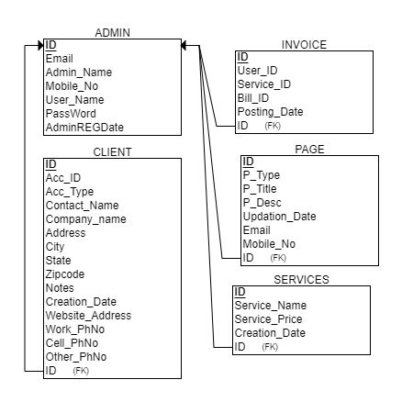

**CHAPTER 5: IMPLEMENTATION**

**5.1 Description of Database Tool (Backend)**

The Database used was MySQL, MySQL is an open-source relational database management system (RDBMS) that works with an operating system to implement a relational database in a computer storage system, manages users, allows for network access and facilitates testing database integrity and creation of backups. It is most noted for its quick processing, proven reliability, ease, and flexibility of use. It is a stable, reliable and powerful solution with advanced features like Data Security, High Performance, complete workflow control, and flexibility of open source.

The MySQL Database Server is very fast, reliable, scalable, and easy to use. If that is what you are looking for, you should give it a try. MySQL Server can run comfortably ona desktop or laptop, alongside your other applications, web servers, and so on, requiring little or no attention.

The MySQL Database Software is a client/server system that consists of a multithreaded SQL server that supports different back ends, several different client programs and libraries, administrative tools, and a wide range of application programming interfaces (APIs). It also provides MySQL Server as an embedded multithreaded library that you can link into your application to get a smaller, faster, easier-to-manage standalone product.

The MySQL Database Server is very fast, reliable, scalable, and easy to use. If that is what you are looking for, you should give it a try. MySQL Server can run comfortably on a desktop or laptop, alongside your other applications, web servers, and so on, requiring little or no attention.

**5.2 Description of Implementation (Frontend)**

For front-end development, Visual Studio Code was used. Visual Studio Code is a free source-code editor made by Microsoft for Windows, Linux and macOS. Features include support for debugging, syntax highlighting, intelligent code completion, snippets, code refactoring, and embedded Git.

Visual Studio Code is a lightweight but powerful source code editor which runs on your desktop and is available for Windows, macOS, and Linux. It comes with built-in support for JavaScript, TypeScript, and Node.js and has a rich ecosystem of extensions for other languages (such as C++, C#, Java, Python, PHP, Go) and runtimes (such as .NET and Unity).

**PHP:**

The PHP Hypertext Preprocessor (PHP) is a programming language that allows web developers to create dynamic content that interacts with databases. PHP is basically used for developing web-based software applications. This tutorial helps you to build your base with PHP.

**HTML5:**

Hypertext Markup Language revision 5 (HTML5) is a markup language for the structure and presentation of World Wide Web content. HTML5 supports the traditional HTML and XHTML style syntax and other new features in its markup, New APIs, XHTML, and error handling.

**CSS:**

Cascading Style Sheets (CSS) is a style sheet language used for describing the presentation of a document written in a markup language such as HTML. CSS is a cornerstone technology of the World Wide Web, alongside HTML and JAVASCRIPT.

**CHAPTER 6: TESTING**

* 1. **Component Tests:**

Component testing is undertaken when a module has been created and has been successfully reviewed.

Each component of the software was tested individually from adding users as Clients from logins to performing transplant transactions and updating logs and multiple other components were also tested.

**Registration Screen:**

| TEST UNIT | TEST CASE | RESULT |
| --- | --- | --- |
| Registration Screen | clicking on login to admin or client button. | The system takes the user to the login screen. The account has been registered as a user(admin/client) and can perform the login. |

**Login Screen:**

| TEST UNIT | TEST CASE | RESULT |
| --- | --- | --- |
| Login Screen | Providing a registered user id and password | The system takes the user to their respective Dashboards. |
| Login Screen | Providing login details that do not match registered credentials | The system does not grant access to the user/admin and shows an error message |

**Donate and Procure/ Admin Functions:**

| TEST UNIT | TEST CASE | RESULT |
| --- | --- | --- |
| client list /services | Click on tiles to perform search/ Add. | The user is displayed with selected data & availed to register a service. |
| Admin Home | Admin Click on Add/Update/ Remove options | Admin corresponding providing services opens up. |

**Search Invoices:**

| TEST UNIT | TEST CASE | RESULT |
| --- | --- | --- |
| Search Invoices | Click on search invoices | Search gets filtered based on the letters entries and greedy matching occurs successfully |

* 1. **System Test**

The whole system testing was done to evaluate the efficient working of the software. All the bugs that were found were sorted out.

Our Project went through two levels of testing

* + 1. **Unit Testing**

Unit Testing is a type of software testing where individual units or components of a software are tested. The purpose is to validate that each unit of the software code performs as expected. Unit Testing is done during the development (coding phase) of an application by the developers.

**6.2.2 Integration Testing**

Integration Testing is defined as a type of testing where software modules are integrated logically and tested as a group. A typical software project consists of multiple software modules, coded by different programmers. The purpose of this level of testing is to expose defects in the interaction between these software modules when they are integrated.

| TEST UNIT | TEST CASE | RESULT |
| --- | --- | --- |
| Sign Up | Click on the Sign Up button | Takes user to the registration page (New user Registration Form) |
| Login | Click on login button | The system takes the user to their dashboard And admin dashboard |
| Responsive Design | Resize window | System design, including navbar, sizing, styling,changes |
| Navbar Button | Click on Userhome/Home | The tab userhome/Admin Home Opens |
| Add a  entity(client,admin) | Fill Form and click on add button | New User added and success message displays, if failure error message displayed |
| search saved | Saved data button is clicked | Previously Stored entries are successfully displayed and sorted, user can search key words. |
| Add Transactions | Fill form for transaction | Admin corresponding providing services opens up. |
| Logout | Click on the logout button | Successfully logs out from the user/admin account and leads to login page |

**CHAPTER 7: INTERPRETATION OF RESULTS**

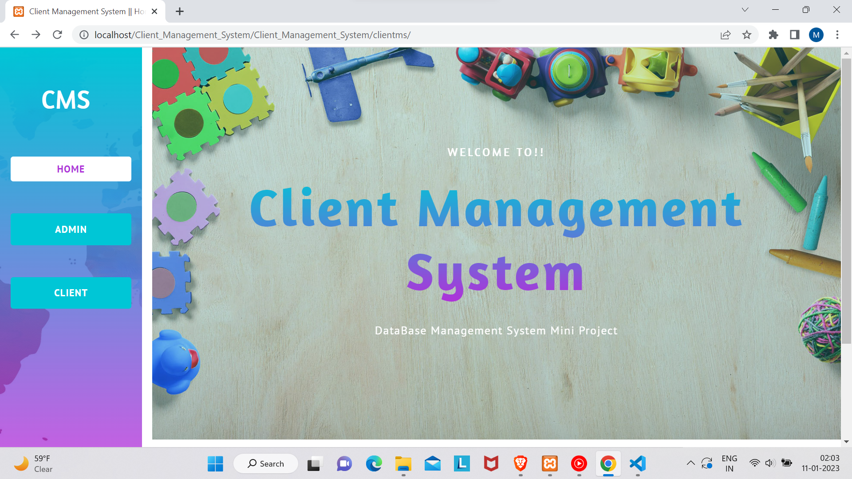

Fig. Home Screen

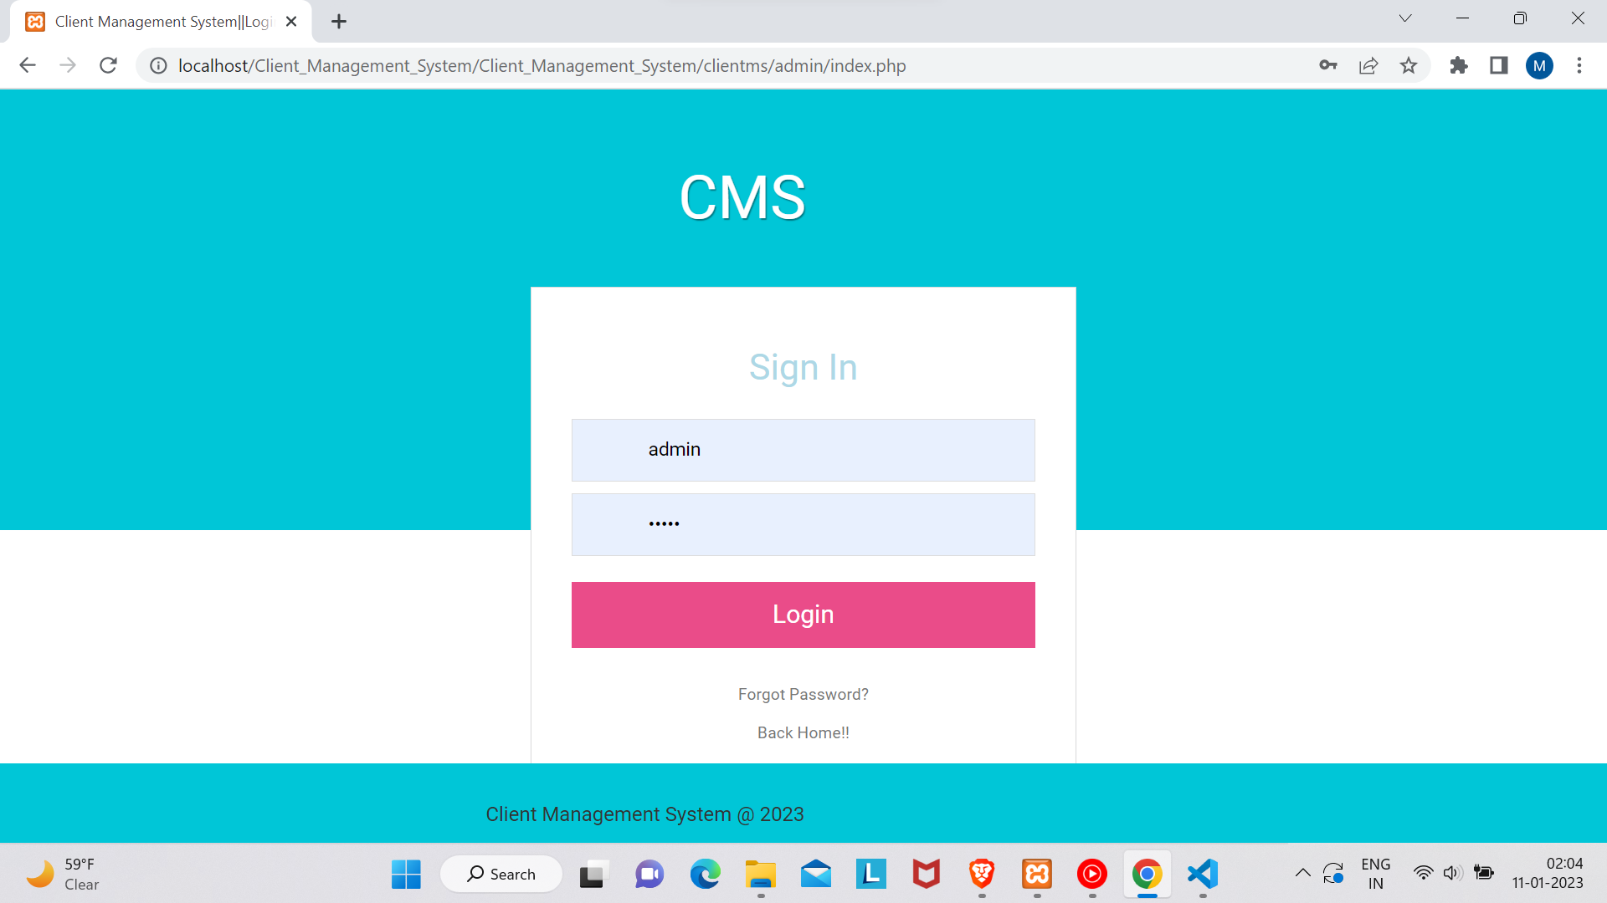

Admin Login

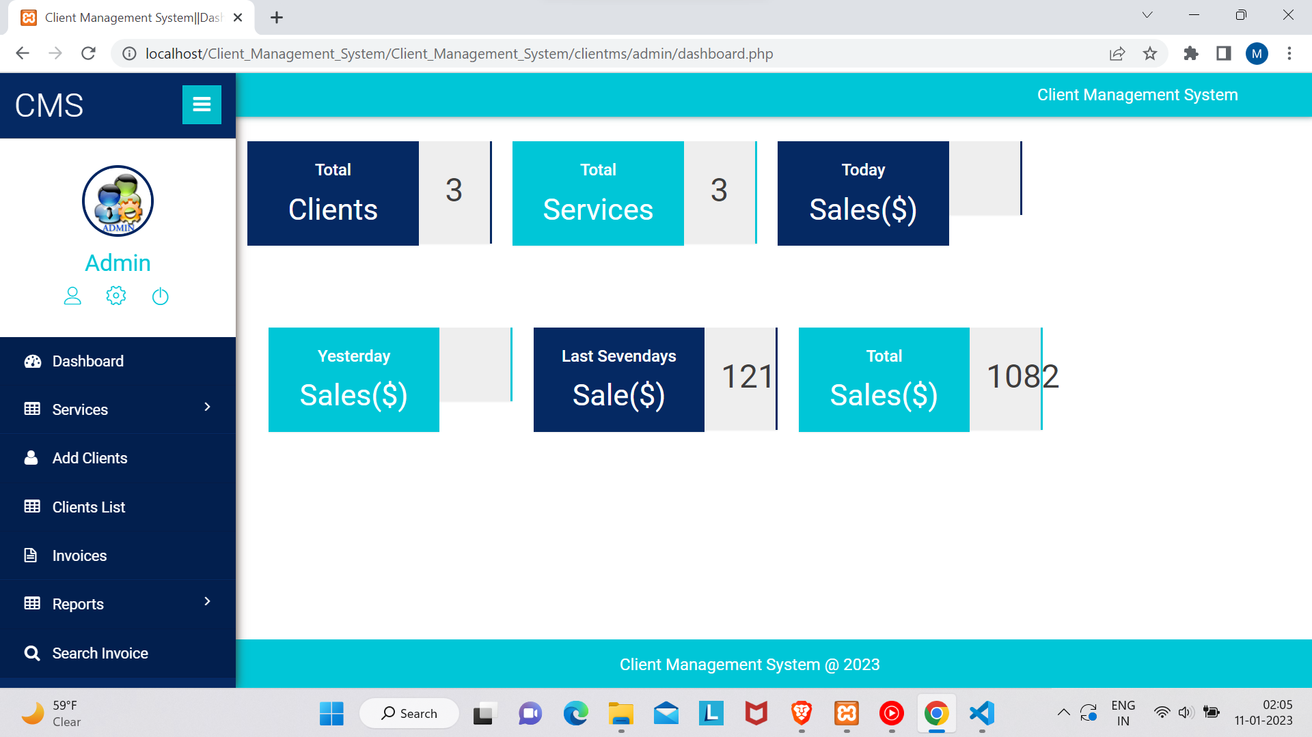

Admin Dashboard

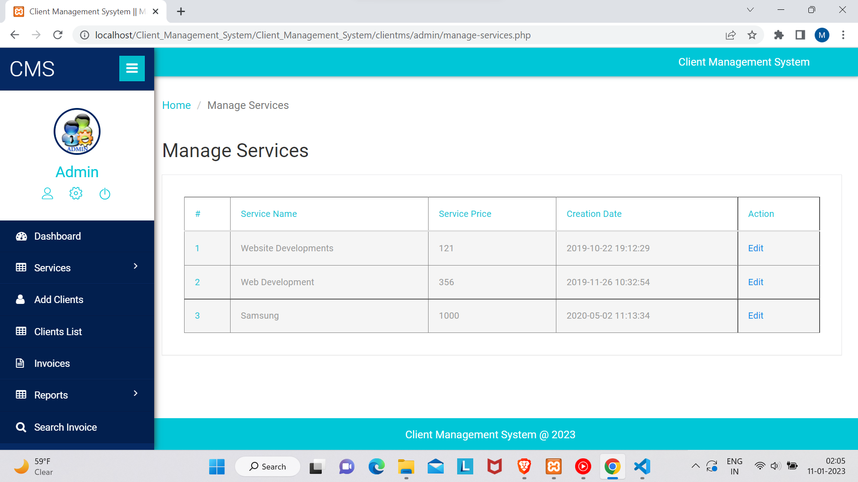

Services

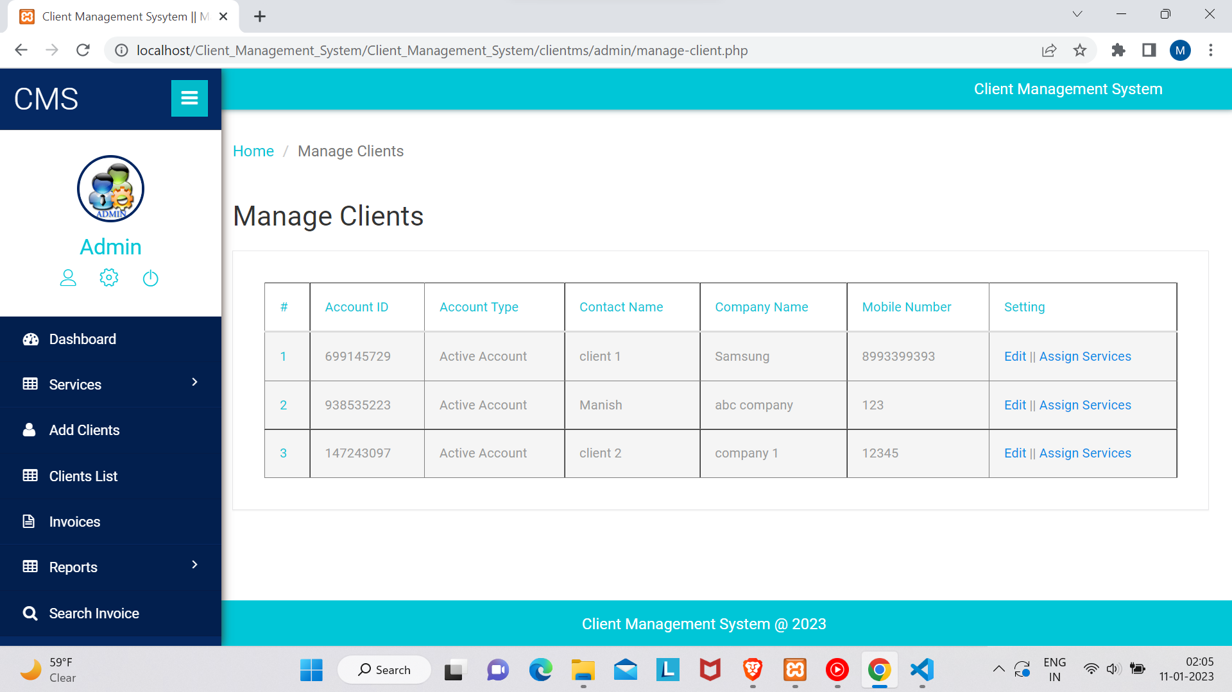

Client management

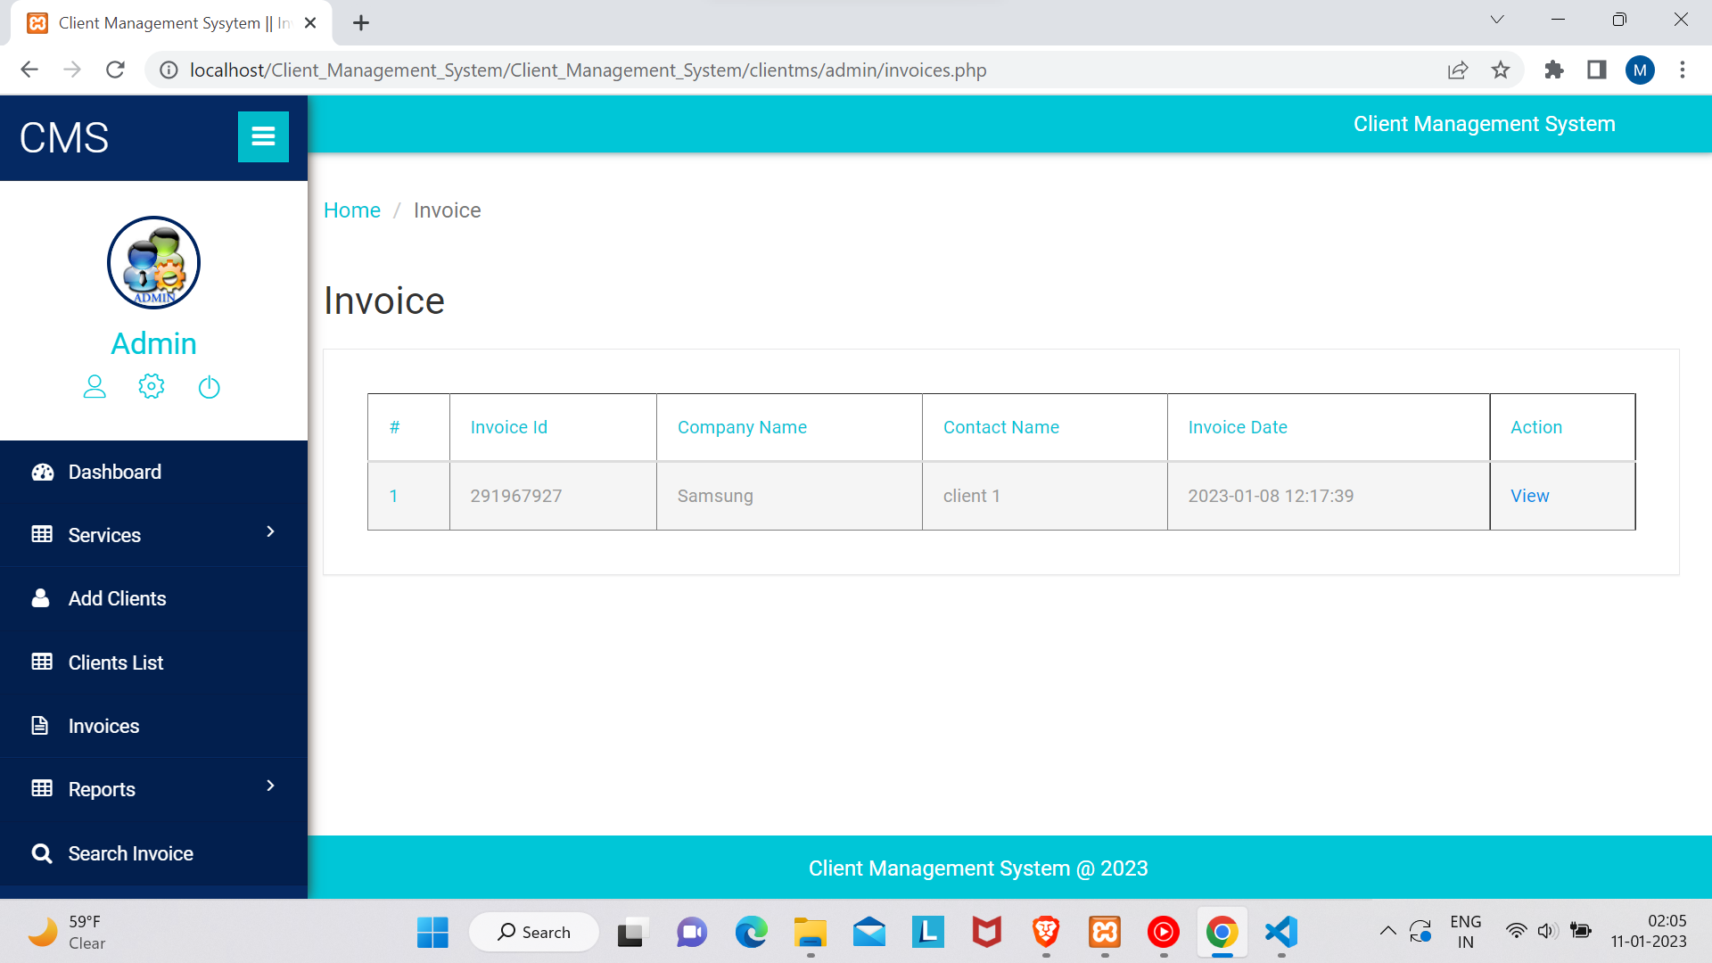

invoices

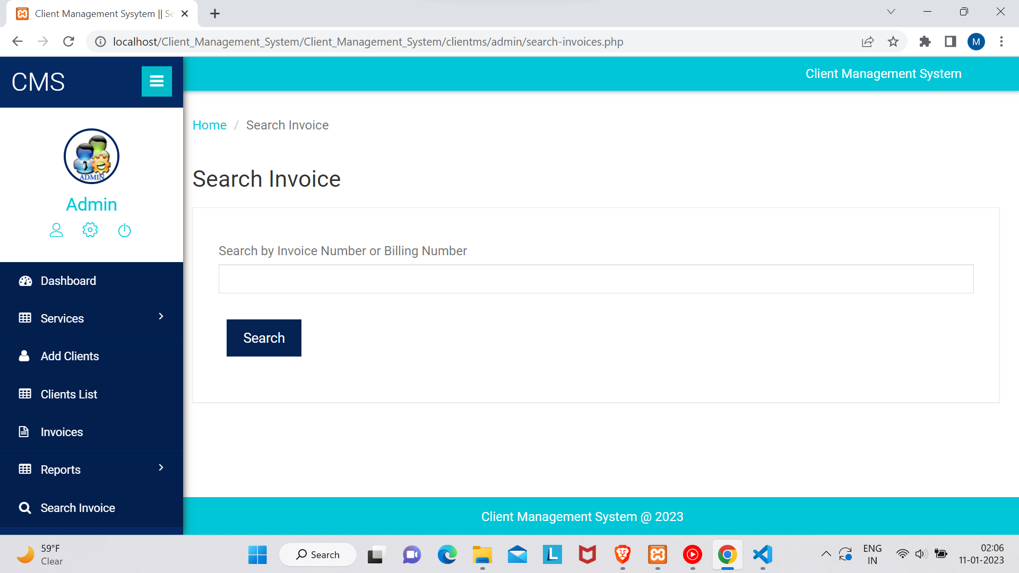

invoice search

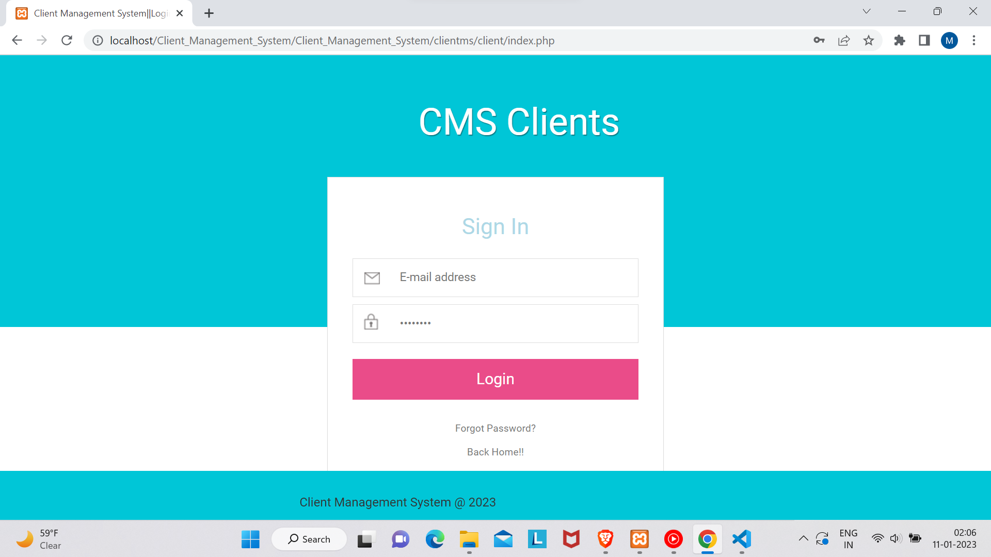

Client login

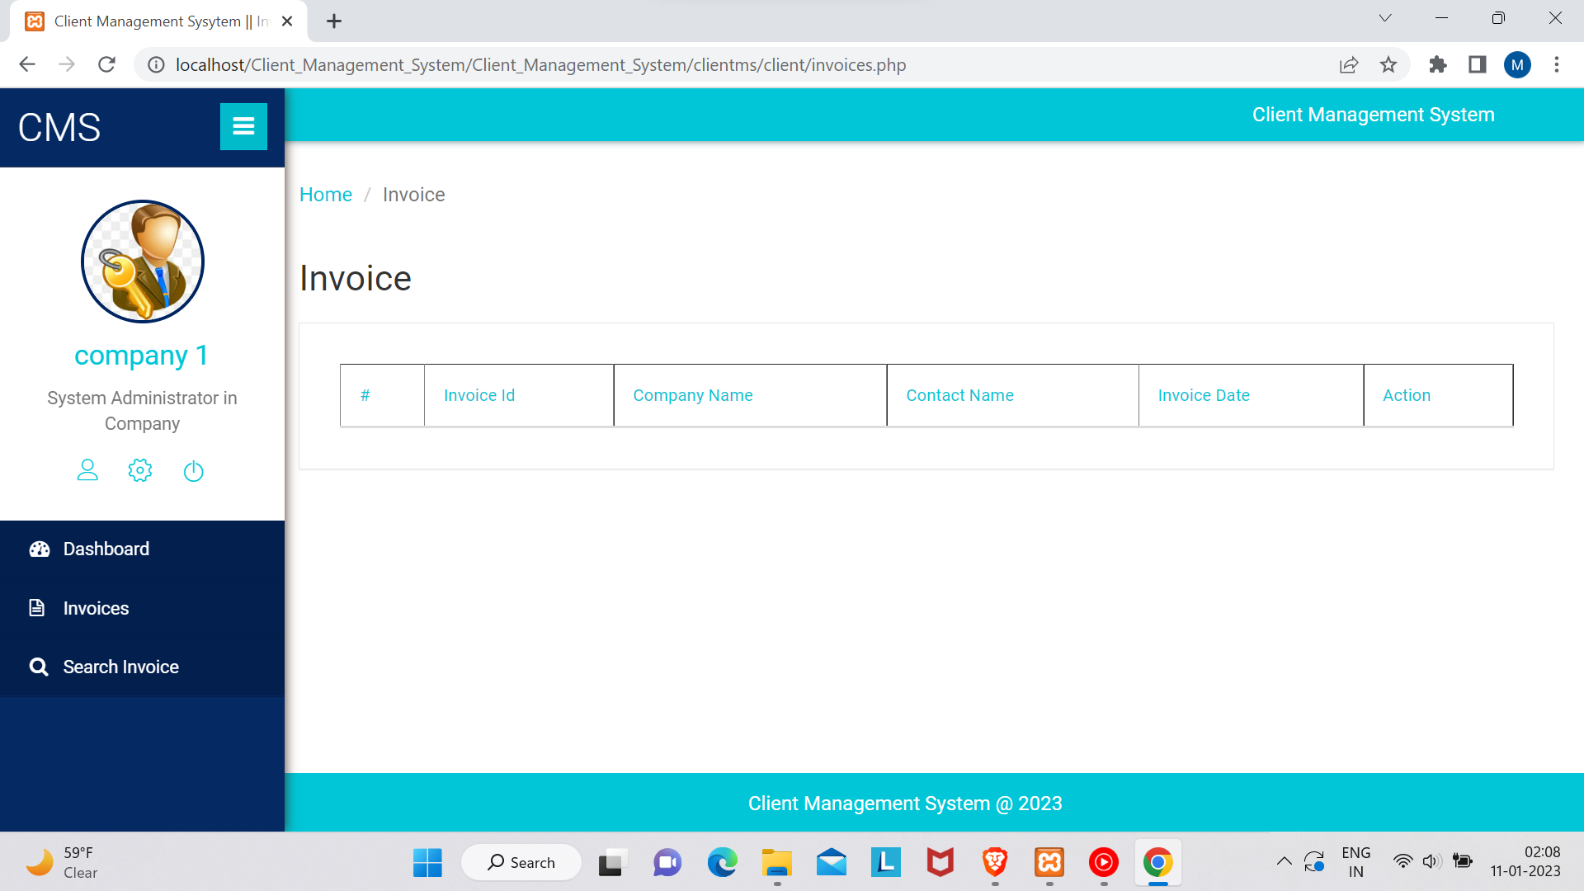

Client Dashboard

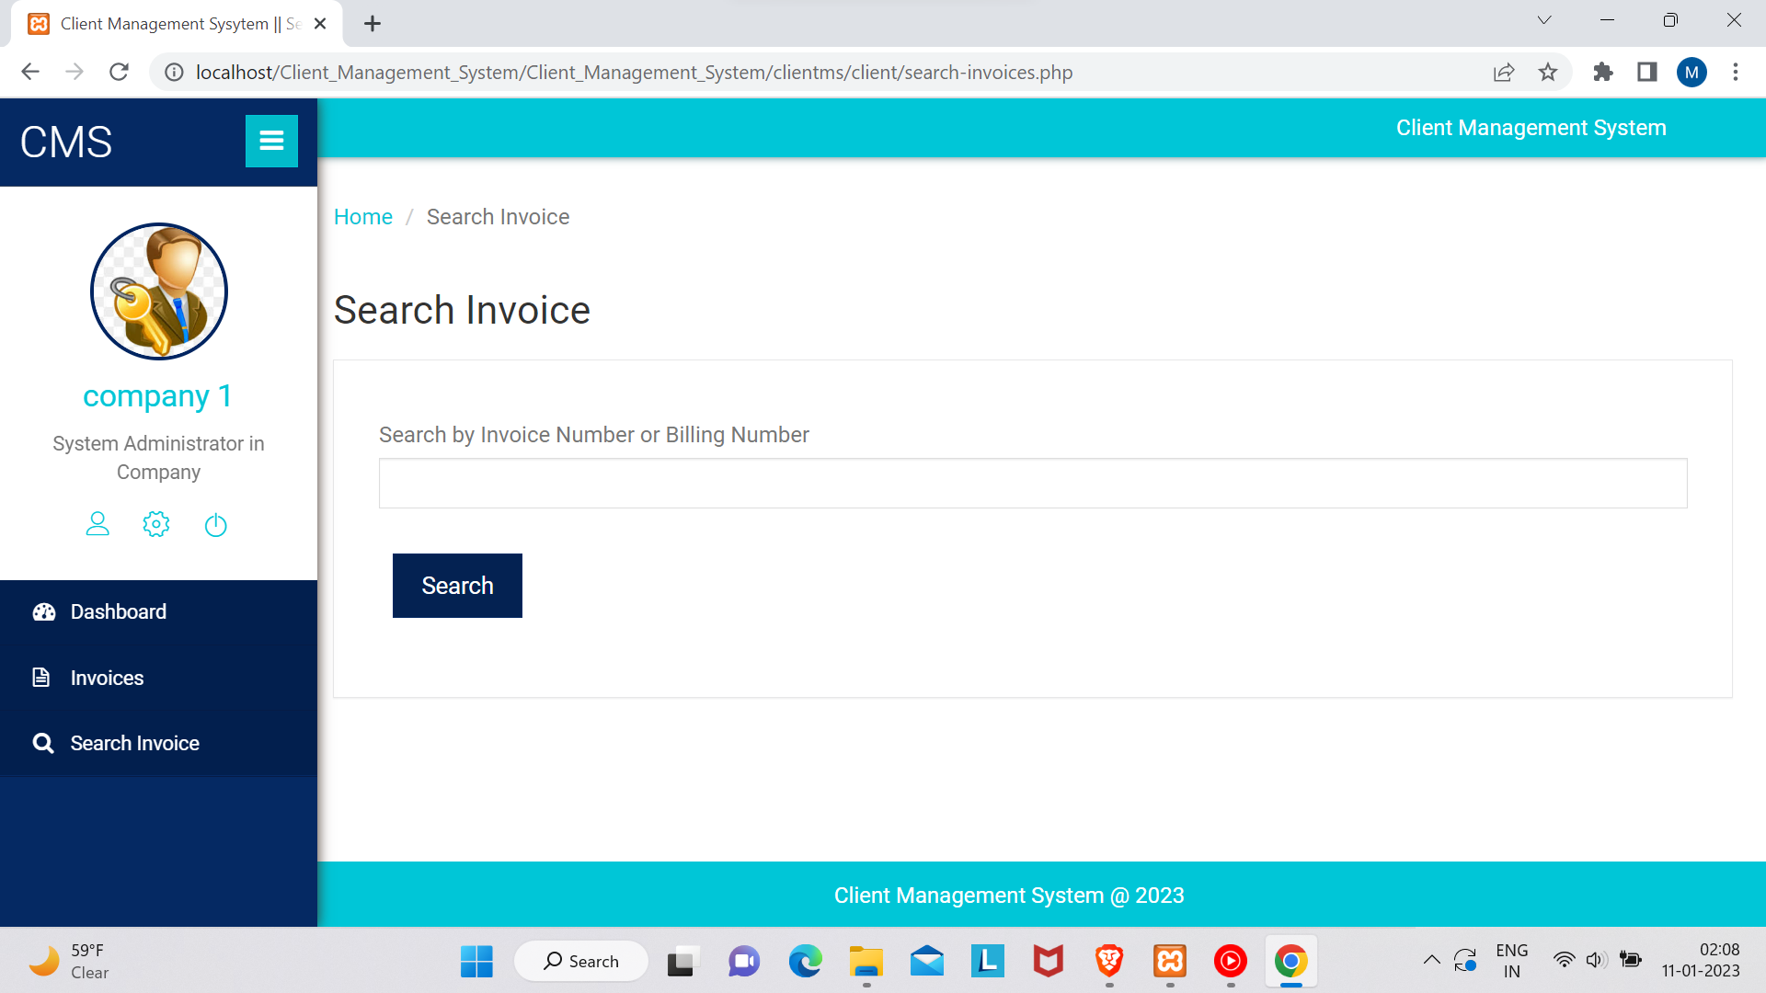

invoice Search

**CONCLUSION**

This client management application provides the facility to provide service anywhere and anytime. I save time since the client does need to wait for results. So the admin/client can access data seamlessly. All clients get extra services in plenty no of fields such as IT, management, etc. The administrator has the privilege to put as many as services in any category given in the application. The client can register, log in, and take the service of any given company with his/her specific id, and can see the reports as well.

In near Future, we will try to update many features on our website which can be used by

any organization in view of the growing needs of technology.



**REFERENCES**

* <https://esource.dbs.ie/handle/10788/3494>
* <https://dev.mysql.com/doc/>
* [https://www.mysqltutorial.org/](https://dev.mysql.com/doc/)
* [https://www.organindia.org](https://dev.mysql.com/doc/)
* [https://visualstudio.microsoft.com/](https://dev.mysql.com/doc/)
* <https://dev.mysql.com/doc/>
* <https://www.tutorialspoint.com/php/index.htm>

[](https://www.tutorialspoint.com/php/index.htm)

* Fundamentals of Database Systems, Ramez Elmasri and Shamkant B. Navathe, 7th Edition, 2017, Pearson.
* Database management systems, Ramakrishnan, and Gehrke, 3rd Edition, 2014, McGraw Hill.

**Department Vision & Mission**

